


SCHOOL OF COMPUTER APPLICATIONS

NO SQL AND DBAAS 101(NO SQL)
(BCADSN13202)

Submitted To: - Mr. Ankit Verma
Submitted By: - Name: Anuj Srivastava
Section:BCADS22
Roll Num: 1240258108

PROJECT DESCRIPTION PAGE

🎯 Project Title:
Student Performance Analysis using NoSQL Database.

Objective:
  - The main objective of this project is to design, store, and analyze academic data using a NoSQL database.
It aims to demonstrate how NoSQL databases such as MongoDB can efficiently manage large, unstructured, and hierarchical data while supporting advanced queries, aggregation, and analytics.

📂 Project Description:
This project focuses on implementing a NoSQL-based data model for managing student academic records.
Unlike traditional relational databases, NoSQL databases offer schema flexibility, faster scalability, and better handling of complex data such as arrays and subdocuments.

⚙ Tools & Technologies Used:
• Database: MongoDB (NoSQL)
• Query Interface: Mongo Shell / MongoDB Compass
• Language (optional): Python / Node.js (for connection and queries)
• Data Source: Student Academic Dataset (JSON / CSV)

📊 Problem Statements Covered:
- Complex Filters & Projections.
- Joins ($lookup) and Aggregations
- Grouping, Sorting, and Limiting.
- Update, UPSER, and Delete
- Array & Operator Usage.
- Subdocuments and Nested Conditions.
- Advanced Aggregation (Challenge Level).

PROJECT

Problem Statements-1: Complex Filters & Projections.

- Filters are used to select documents that match specific criteria in a NoSQL collection.
- Projections specify which fields to include (or exclude) in the output.

Question:-1

List the names and departments of students who have more than 85% attendance and are Skilled in both "MongoDB" and "Python"

Query : - db.students_full.find({ attendance: { $gt: 85 }, skills: { $in: ["MongoDB", "Python"] }})

  - Output:-

- Nothing will show up because there aren’t any students who have both ‘MongoDB’ and ‘Python’ skills and more than 85% attendance.
- Use comparison operators like $gt (greater than).
- Apply array matching with $all to ensure multiple elements exist.
- Use projection to show only required fields.
- Build compound filters using multiple conditions.

Question:-2

Show all faculty who are teaching more than 2 courses. Display their names and the total number of courses they teach.

Query : -
db.faculty_full.aggregate(
[{ $project: { name: 1, totalCourses: { $size: "$courses" }}},
{ $match: { totalCourses: { $gt: 2 }}}])

  - Output:-

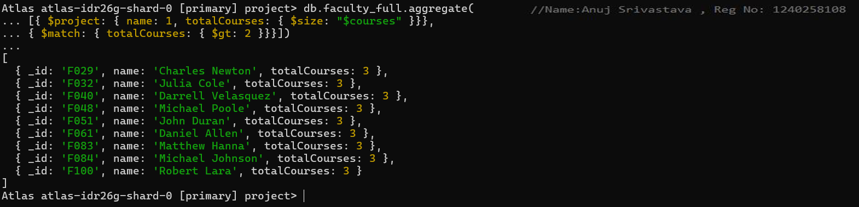

- Use $project to create computed fields
- Use $size to count array elements.
- Combine $match after projection for conditional filtering.
- Understand aggregation pipelines

Problem Statements-2:

Joins ($lookup) and Aggregations.

- MongoDB is a document-oriented NoSQL database, so it doesn’t have traditional SQL joins. But you can join collections using $lookup in an aggregation pipeline.
- MongoDB uses the Aggregation Framework to process data like SQL GROUP BY, SUM, COUNT, AVG.

Question:-3

Write a query to show each student’s name along with the course titles they are enrolled in (use $lookup between enrollments, students, and courses).

- Query & Output:-
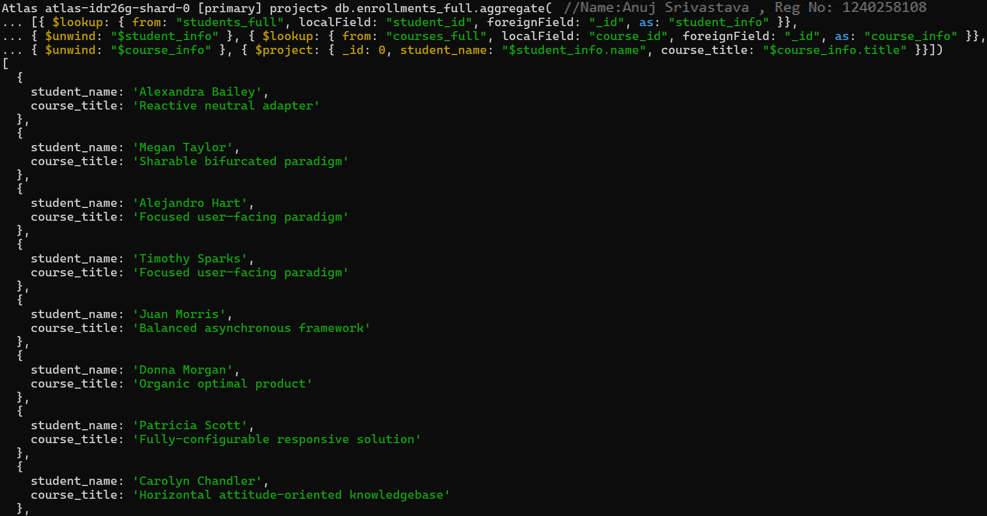

- Insights:
- Use $lookup for joins between collections.
- Use $lookup for joins between collections.
- Use $arrayElemAt to extract single values from arrays.
- Understand MongoDB’s relational-like linking.

Question:- 4

For each course, display the course title, number of students enrolled, and average marks (use $group).

Query & Output:-

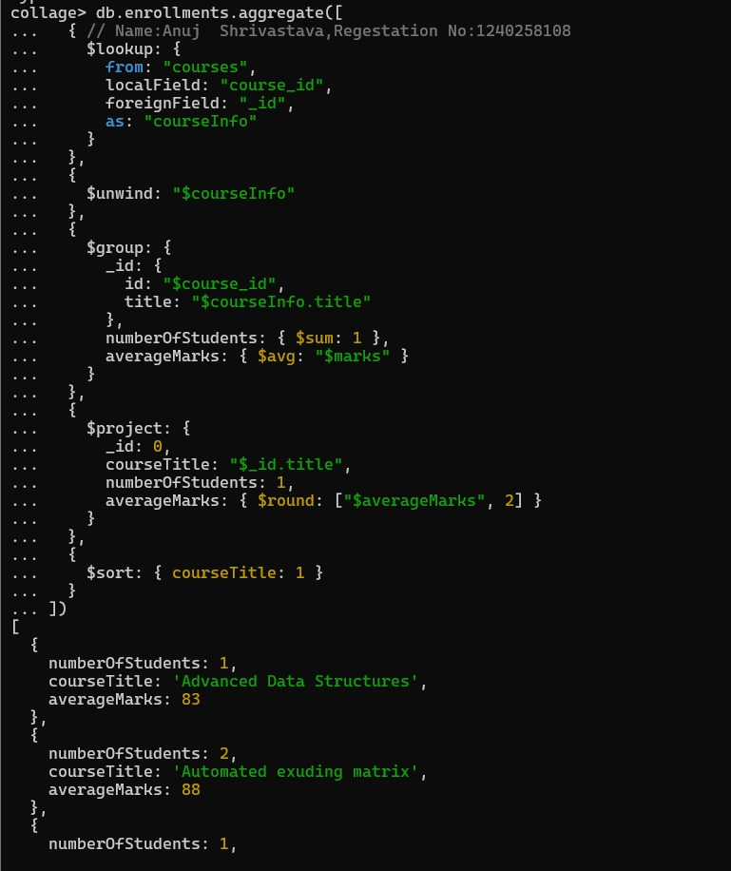

- Insights:
- Use $group for summarizing data.
- Use $avg and $sum to calculate aggregates.
- $unwind helps to deconstruct arrays.
- $project to rename and structure output.

Problem Statements-3:

Grouping, Sorting, and Limiting.

- Grouping - Used to aggregate data — i.e., group records that have the same values in specific fields and apply functions like COUNT, SUM, AVG, etc.
- Sorting- Used to order data based on one or more fields.
- Limiting- Used to restrict the number of results returned by a query.

Question:-5

Find the top 3 students with the highest average marks across all enrolled courses.
- Query & Output:-
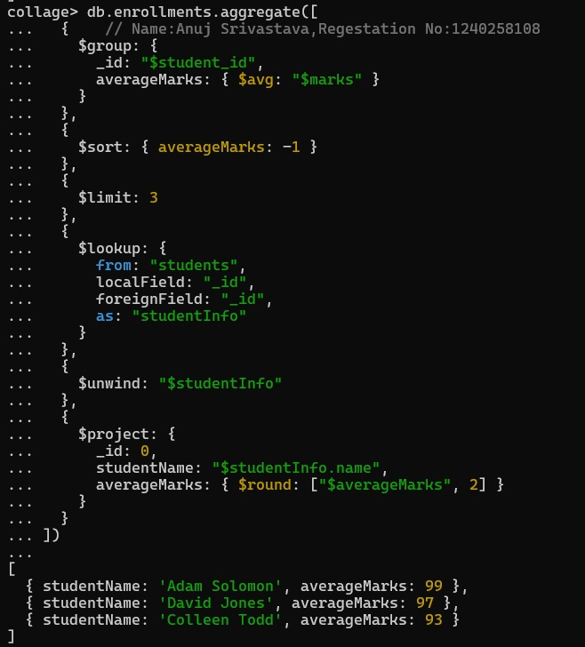

- Insights:
- $sort sorts data in ascending/descending order.
- $limit restricts results to top records.
- $group for calculating averages.
- Combining joins with grouping.

Question:- 6

Count how many students are in each department. Display the department with the highest number of students.

Query & Output:-

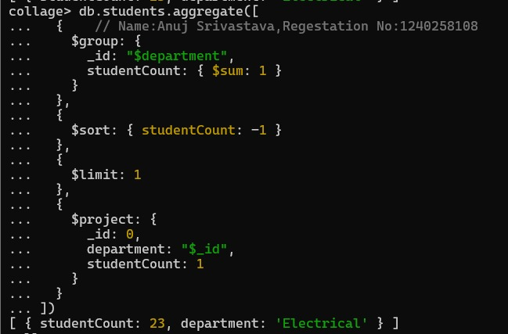

- Insights:
- Count items per category with $sum: 1.
- se $sort to rank results
- Identify top-performing or most populated groups.
- Apply $limit to get top results.

Problem Statements-4: Update, UPSERT, and Delete.

- UPDATE- Used to modify existing data in a collection (NoSQL) or table (SQL).
- UPSERT- Upsert = Update + Insert
If a document exists, it updates it.
If it does not exist, it inserts a new one.
- DELETE- Removes one or more documents/records from a collection/table.

Question:-7

Update attendance to 100% for all students who won any "Hackathon".

- Query & Output:-
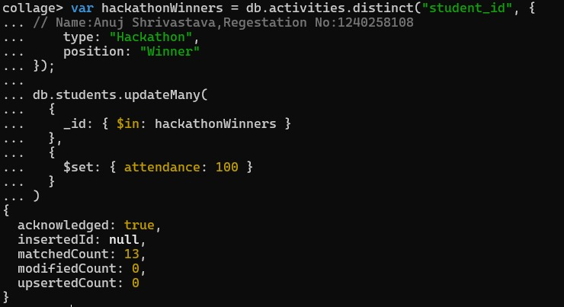

- Insights:
- Use updateMany() for bulk updates.
- $set modifies specific fields.
- Target documents via nested fields.
- Understand bulk updates with filters.

Question:- 8

Delete all student activity records where the activity year is before 2022.

Query & Output:-
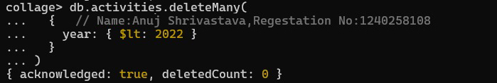

- Insights:
- $lt filters by less than a value.
- Delete records conditionally using deleteMany().
- Manage dataset cleanup.
- Apply conditional data management.

Question:- 9

Upsert a course record for "Data Structures" with ID "C150" and credits 4—if it doesn’t exist, insert it; otherwise update its title to "Advanced Data
Structures".

Query & Output:-

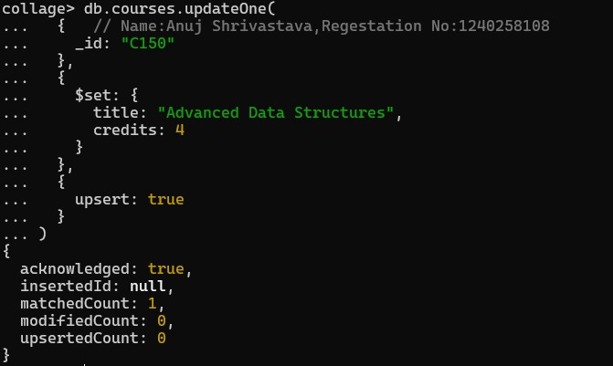

- Insights:
- upsert: true inserts if no match is found.
- $setOnInsert applies only when inserting new data.
- $set updates fields if record exists.
- Handle both insert and update in one commands.

Problem Statements:-5

Array & Operator Usage.

- Arrays in NoSQL- In MongoDB (a document-based NoSQL database), a field can hold an array of values.
- Array Operators - MongoDB provides special operators to query and modify array fields.

Question:-10
Find all students who have "Python" as a skill but not "C++".

- Query & Output:-
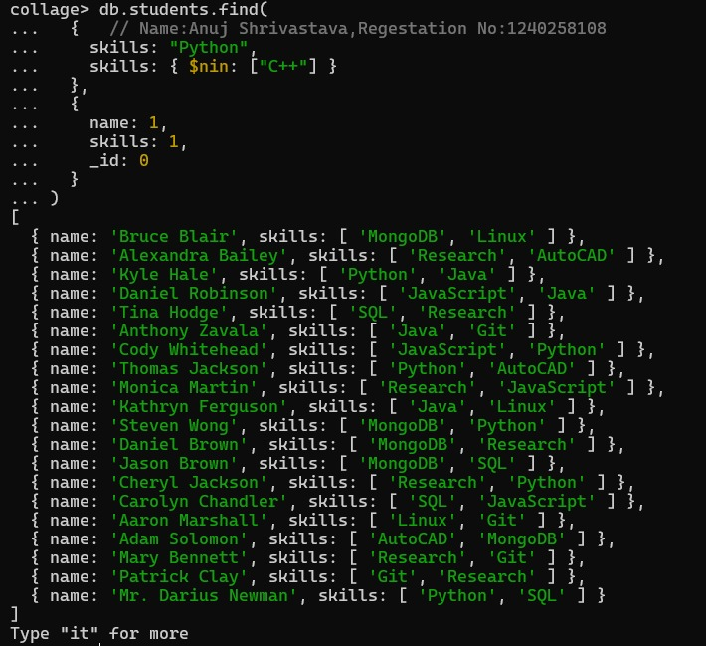

- Insights:
- $in checks for presence in arrays.
- $nin checks for absence in arrays.
- Combine both for exclusive conditions.
- Operate effectively on array fields.

Question:- 11

Return names of students who participated in "Seminar" and "Hackathon" both.

Query & Output:-

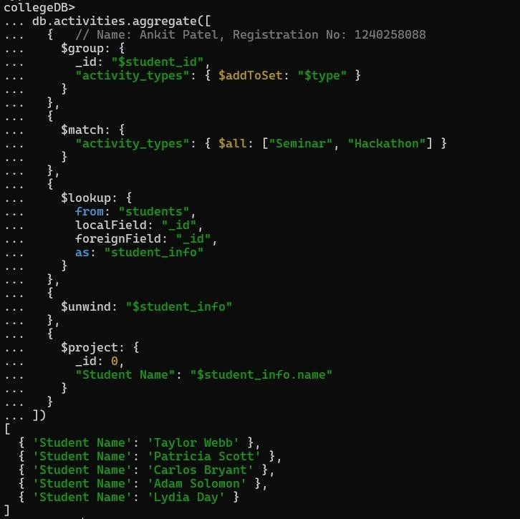

- Insights:
- $all ensures all specified elements exist in an array.
- Simple array querying in MongoDB.
- Combine multiple filters in a single query.
- Efficient participation tracking.

Problem Statements:- 6

Subdocuments and Nested Conditions.

- Subdocuments- A subdocument (or embedded document) is a document inside another document.
- Nested Conditions- Nested conditions allow you to filter based on multiple subdocument fields simultaneously.

Question:-12
Find students who scored more than 80 in "Web Development" only if they belong to the "Computer Science" department.
- Query & Output:-
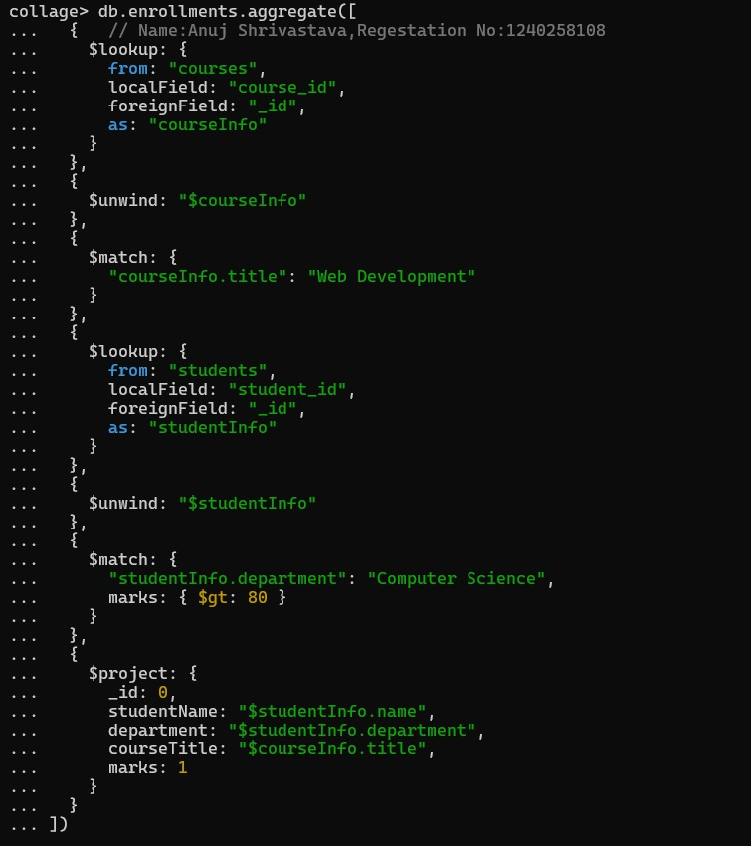

- Insights:
- Nothing will show up because there are no students in the
Computer Science department who scored more than 80 in 'Web Development'. Simple array querying in MongoDB.
- Access nested fields using dot notation.
- Combine multiple field conditions.
- Query subdocuments efficiently.
- Focused filtering by department and performance.

Problem Statements:-7

Advanced Aggregation (Challenge Level).

- Aggregation means processing data records and returning computed results — like totals, averages, or filtered summaries.
- In MongoDB, aggregation is done using the Aggregation Pipeline, where data passes through stages that transform it.

Question:-13
For each faculty member, list the names of all students enrolled in their courses along with average marks per student per faculty.

Query & Output:-
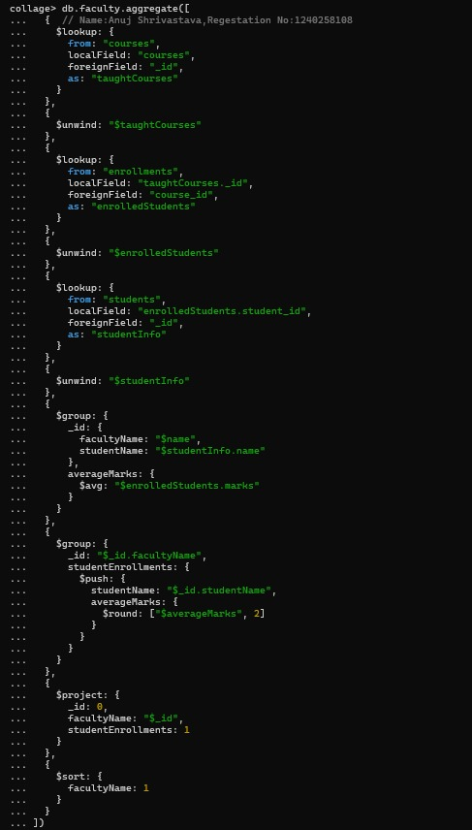

Output:-
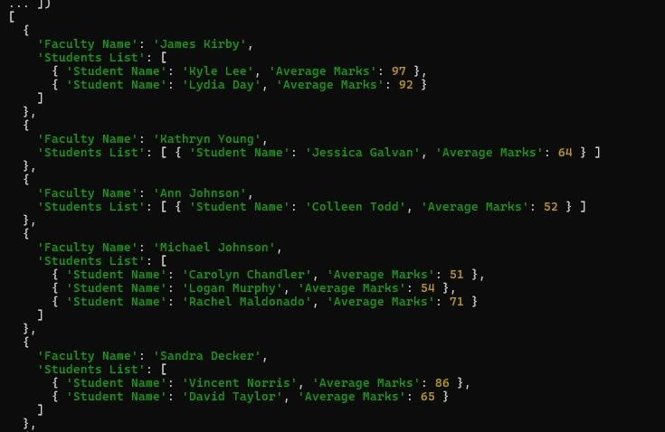

- Insights:
- $ Multi-level joins using $lookup.
- $addToSet to avoid duplicate student names.
- $avg to compute average marks per faculty.
- Real-world aggregation chaining.

Question:-14
Show the most popular activity type (e.g., Hackathon, Seminar, etc.) by number of student participants.

Query & Output:-
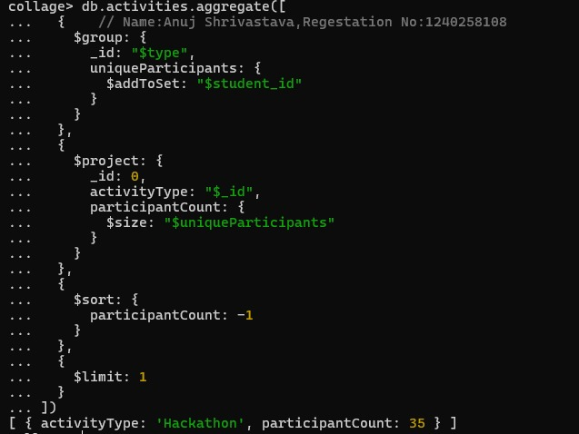

- Insights:
- $unwind to count array elements.
- $group and $sum for totals.
- $sort to rank results.
- Identify “most popular” entities.

